DBSCAN 聚类：

DBSCAN(eps=0.946, min_samples=230)

Partial Dependence Plot (PDP)

pdp_display=PartialDependenceDisplay.from_estimator(clf, X_train, features)

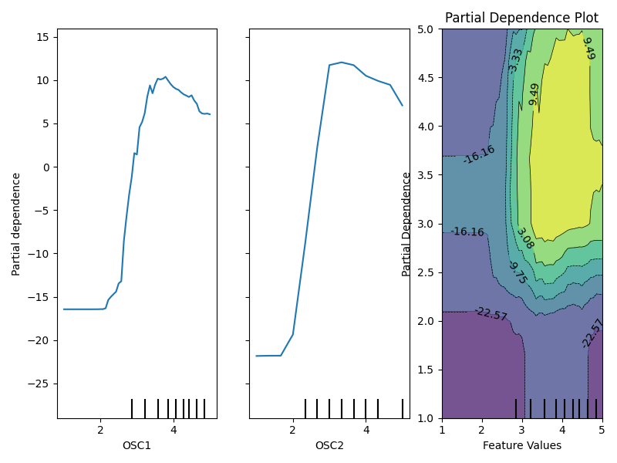

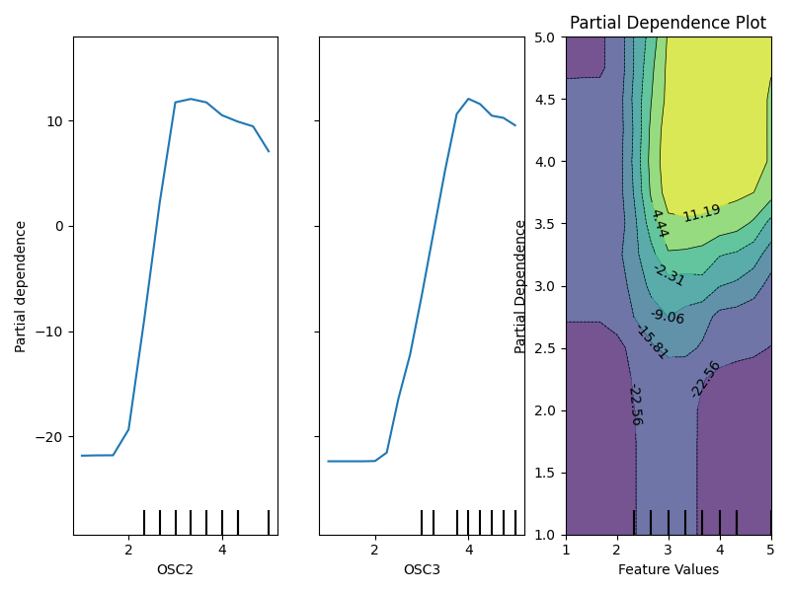

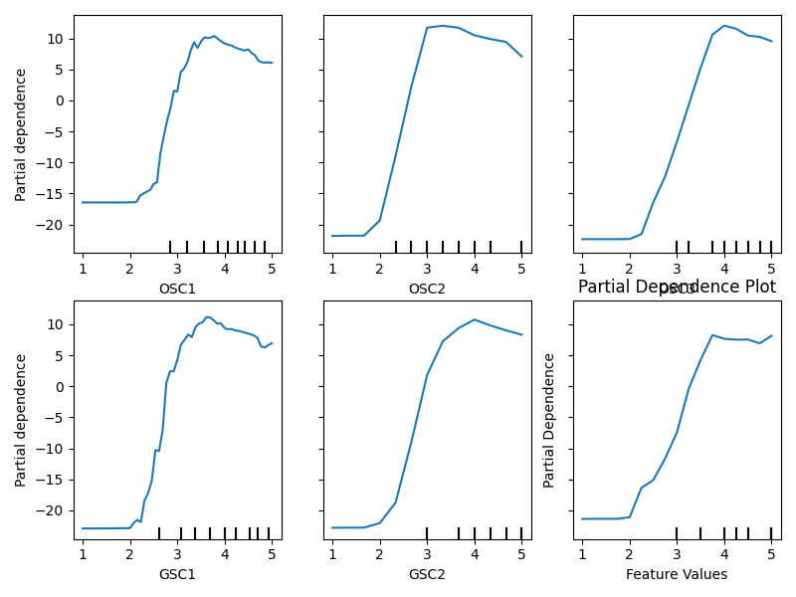

Individual Conditional Expectation (ICE),

pdp_display=PartialDependenceDisplay.from_estimator(clf, X_train, features,kind='both', centered=True)

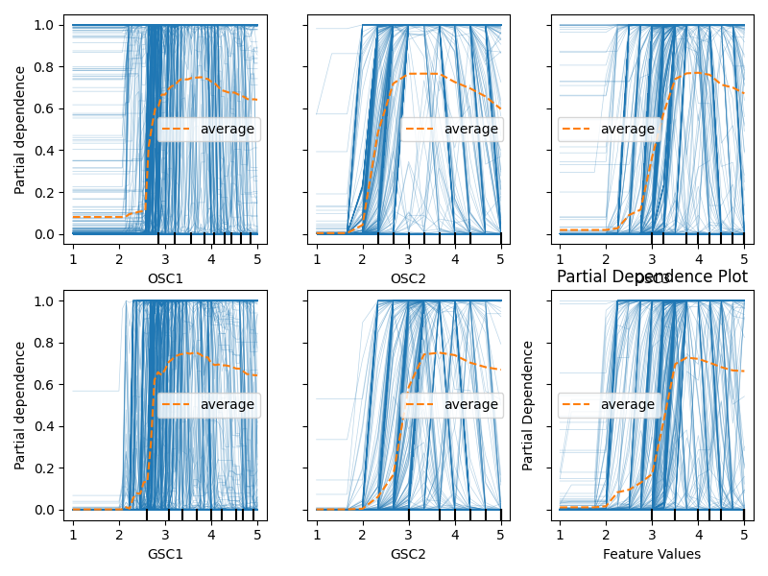

Shapley Value (SHAP)

explainer = shap.Explainer(clf)  
shap_values = explainer(X_test)  
shap.plots.bar(shap_values, max_display=10)

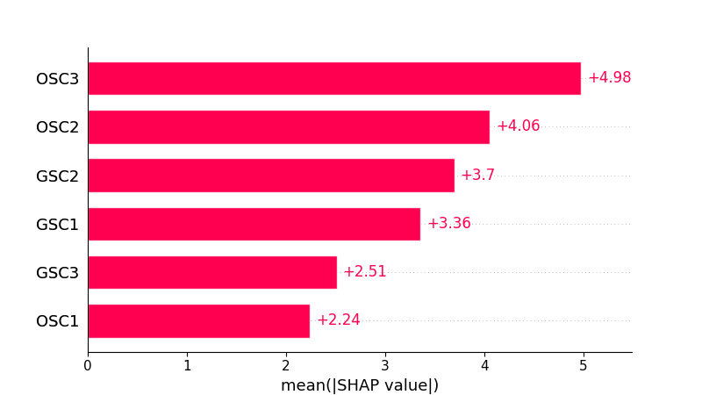

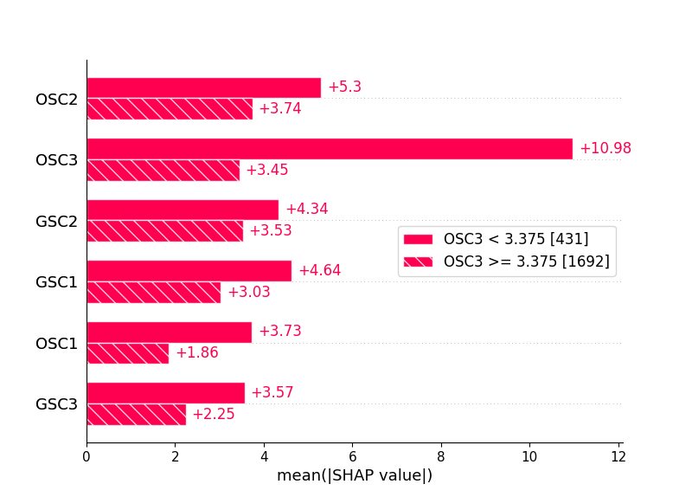

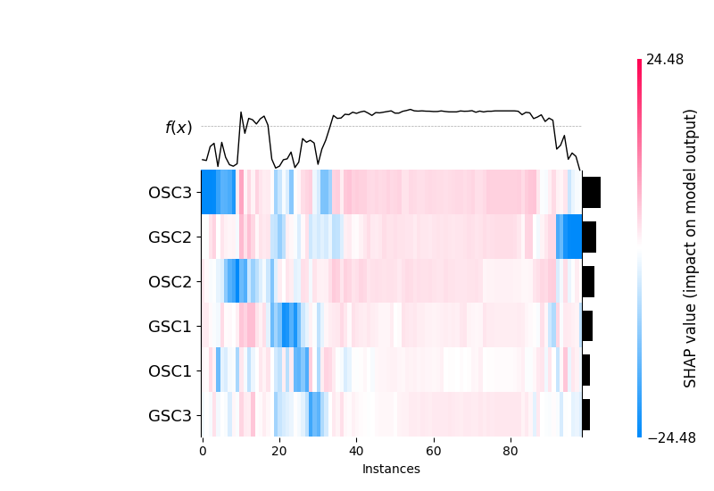

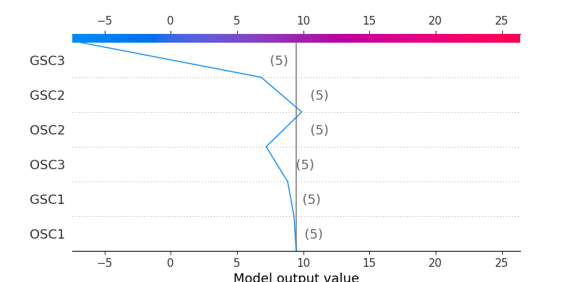

Kmeans 聚类

：

m = KMeans(n_clusters = 2, init = 'k-means++', random_state=0)  
m.fit(X)

Partial Dependence Plot (PDP)

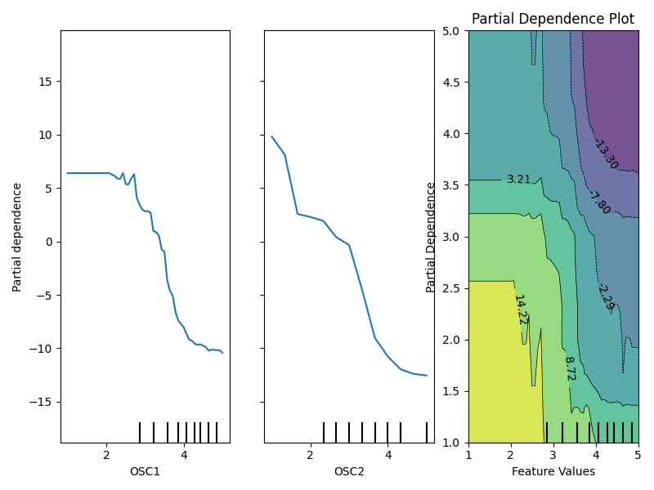

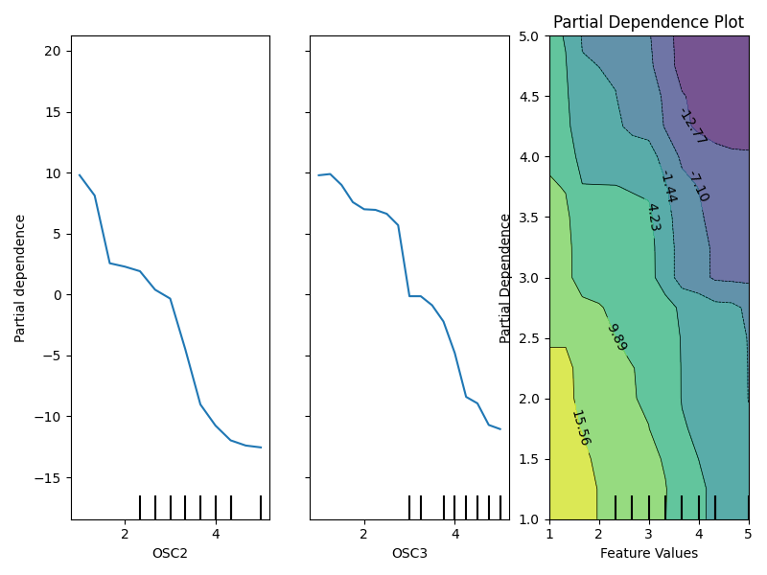

Individual Conditional Expectation (ICE),

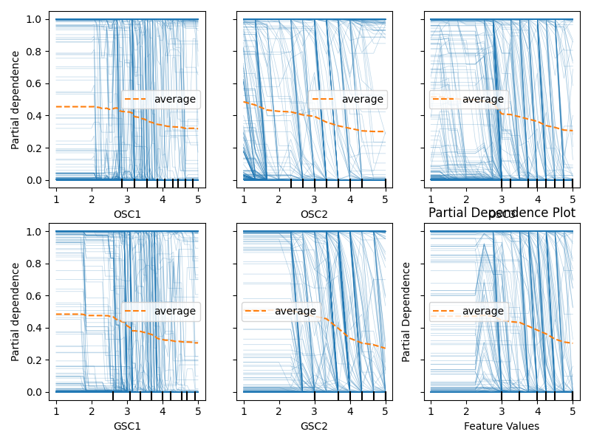

Shapley Value (SHAP)

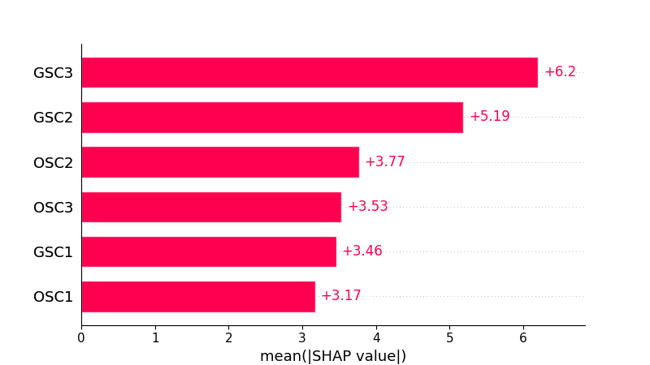

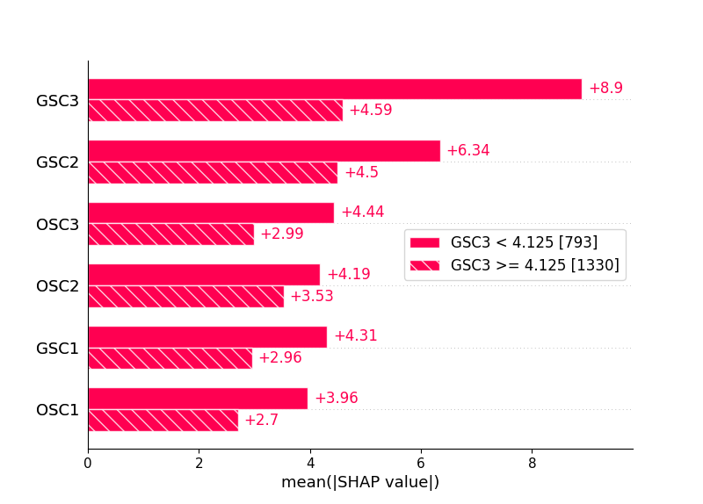

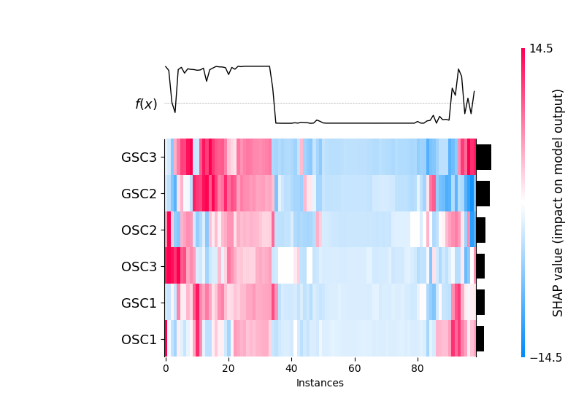

分层聚类

m = AgglomerativeClustering(n_clusters=2)

Partial Dependence Plot (PDP)

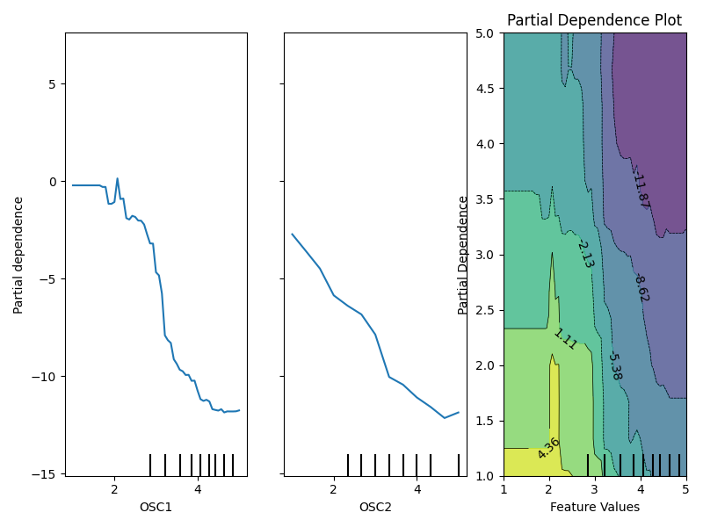

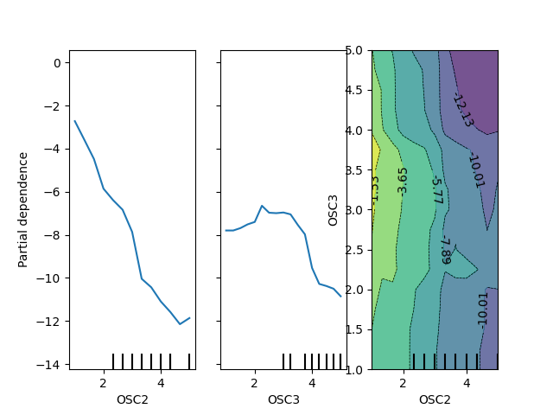

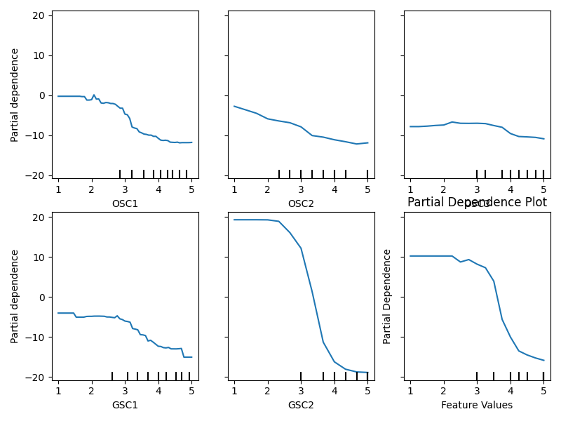

Individual Conditional Expectation (ICE),

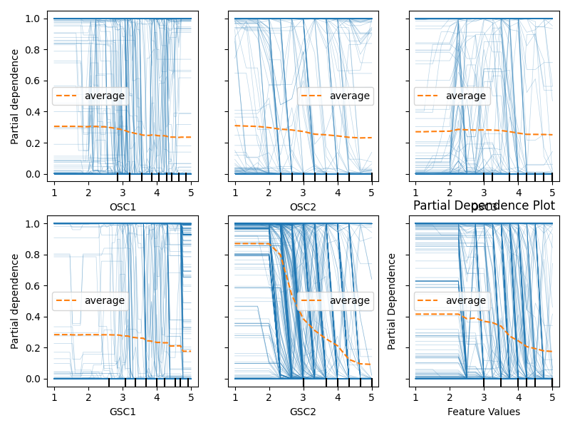

Shapley Value (SHAP)

